Deployment 2

Okay so I wanted to do this over; with better documentation because I really mangled the first one into a solution. If my own notes work again; I did it. If not. Then well I do better the second time.

Used my jenkins script to create ec2 – security group for jenkins opening port 22, 80, 8080

sudo apt-get update -y
sudo apt -y install openjdk-11-jre
curl -fsSL https://pkg.jenkins.io/debian-stable/jenkins.io.key | sudo tee \
/usr/share/keyrings/jenkins-keyring.asc > /dev/null
echo deb [signed-by=/usr/share/keyrings/jenkins-keyring.asc] \
https://pkg.jenkins.io/debian-stable binary/ | sudo tee \
/etc/apt/sources.list.d/jenkins.list > /dev/null
sudo apt-get update
sudo apt-get -y install jenkins
sudo systemctl start jenkins

Waited for the instance to create Jenkins instance and start running.
Installed default plugins

sudo su passwd jenkins – made jenkins password jenkins (yea bad practice but this is testing)
THEN did sudo usermod -aG sudo jenkins as well as adding jenkins to the sudoers file
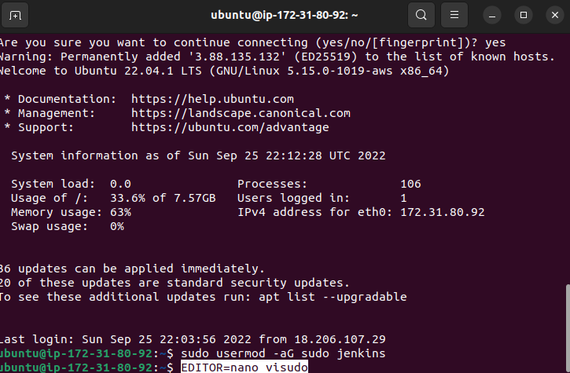

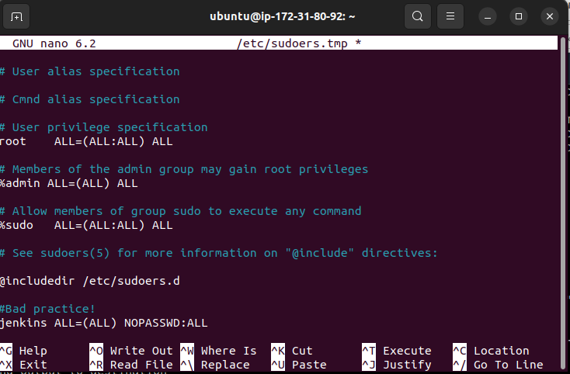
Unlike the recommendation, switched to jenkins account just using
“sudo su jenkins -s bin/bash”
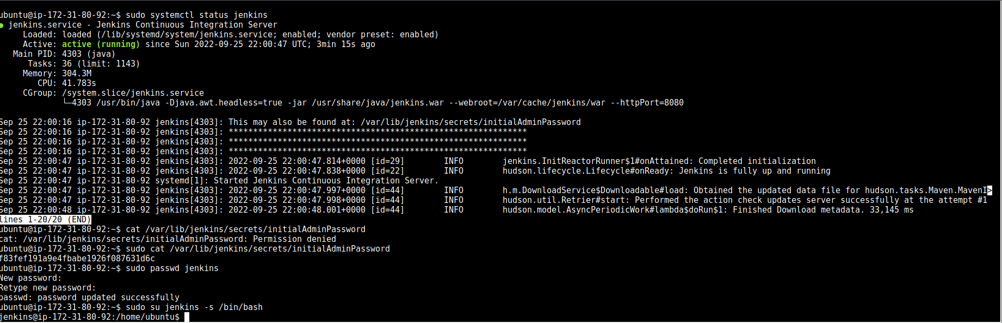
This placed me in the home/ubuntu folder instead of sending me to an entirely different directory

EB-User was created in AWS and given the administrator access policy – copied the token for future use

for the curl command; to avoid permission denied; added sudo
unzip command was not found on the ec2

$sudo apt-get install unzip
sudo unzip awscli2.zip
THIS IS ALL DONE INSIDE UBUNTU HOME
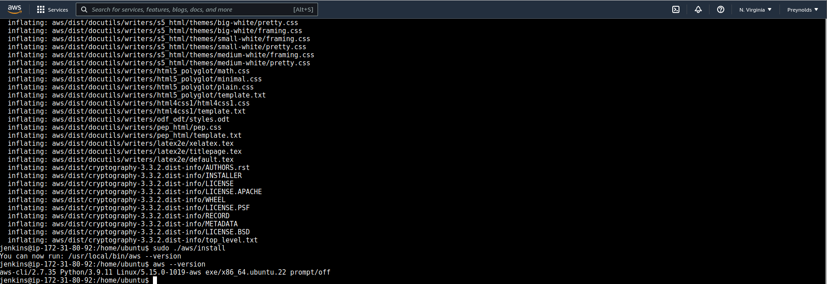

Afterwards to even get started on awscli I need python3.

$sudo apt-get install python3-pip
Jenkins.service restarted.
$sudo apt-get install python3.10-venv (FOR JENKINS BUILDS)

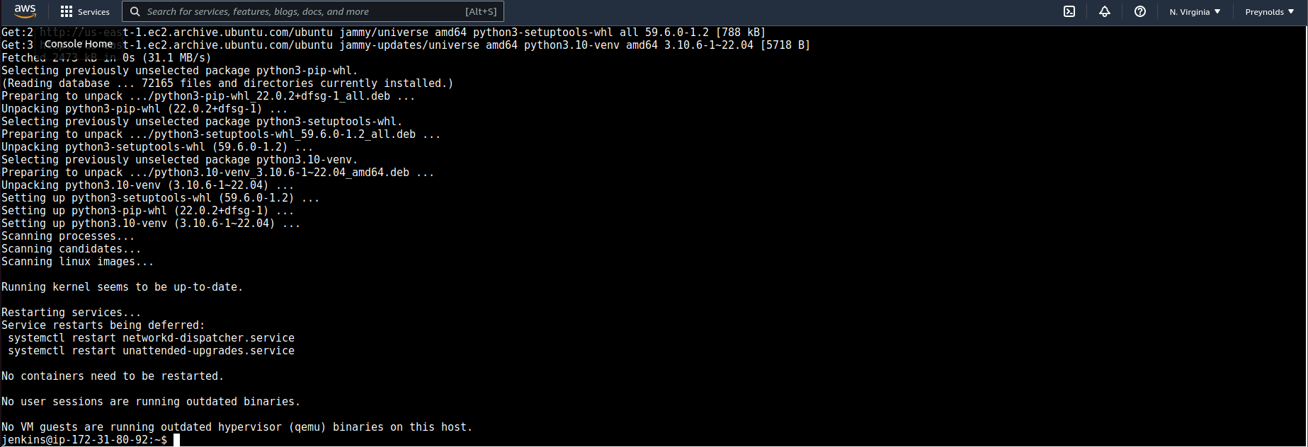

This is where it gets mangley
$pip install awsebcli --upgrade –user

This installs successfully – but if you run eb –version you’d get nothing, since it’s not on $PATH
navigate to ubuntu’s home (swap to it, or open new terminal) and add /var/lib/jenkins/.local/bin to PATH
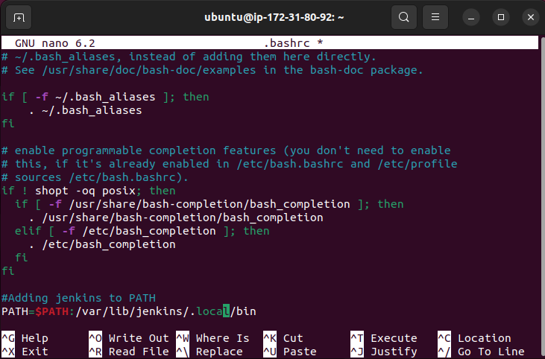

As shown above.
Check ls -a for jenkins ; if .bash_profile is present; modify that.
Add the following lines
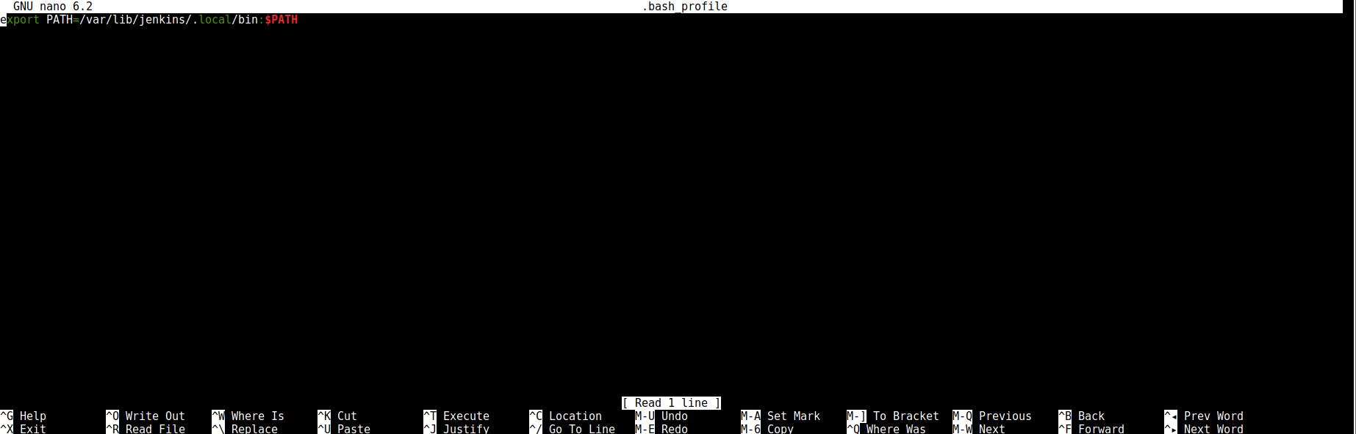
If not present, then touch .bash_profile and add the line.
EB CLI should then run normally.

Go back to jenkins; give it github credentials and build
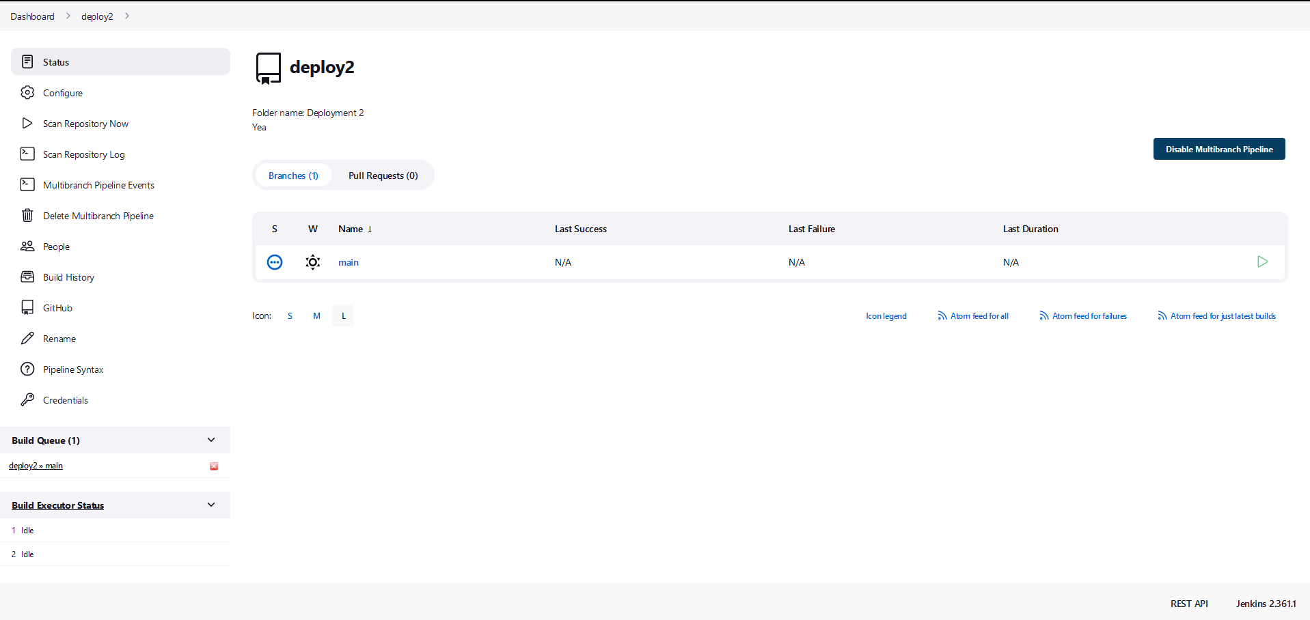

Similar to deployment 1
Found the workspace by checking Jenkins “last build”
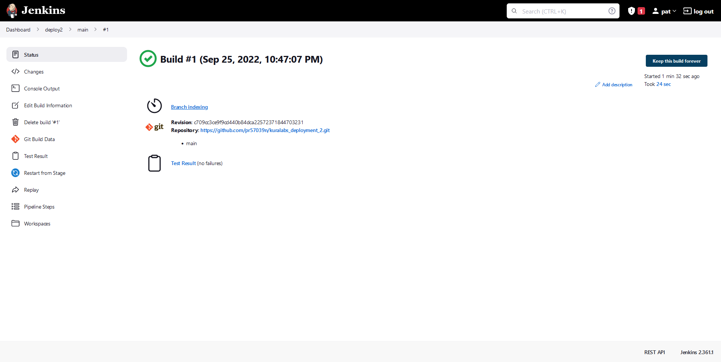

Then checked workspaces
cd to that location THEN run eb init
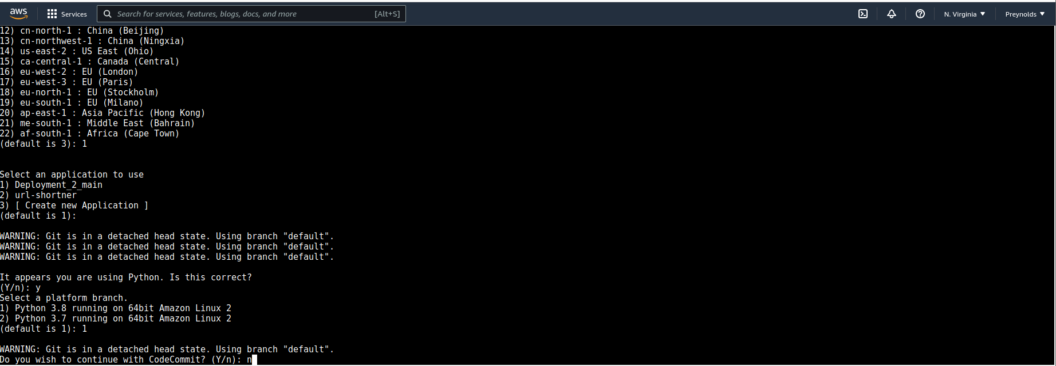

Answered accordingly.
Set up SSH with my usual deployment key
$eb create
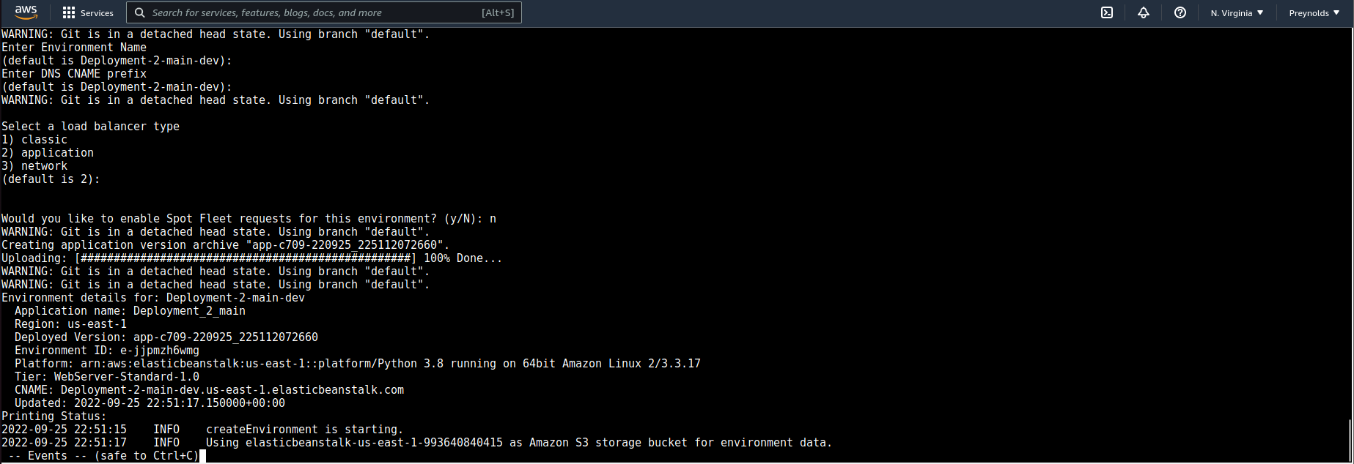

Waited for environment to be made
environment name Deployment-2-main-dev
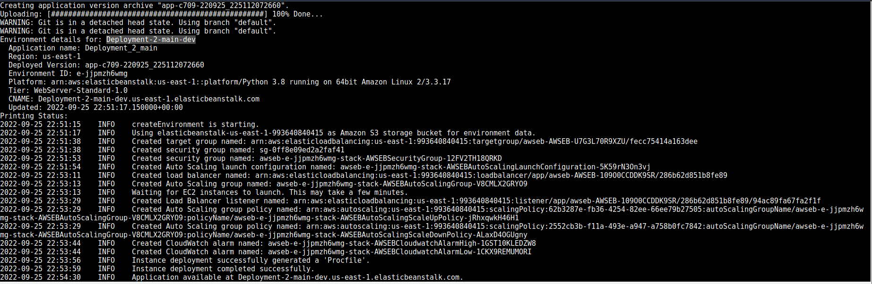

Once available checked site
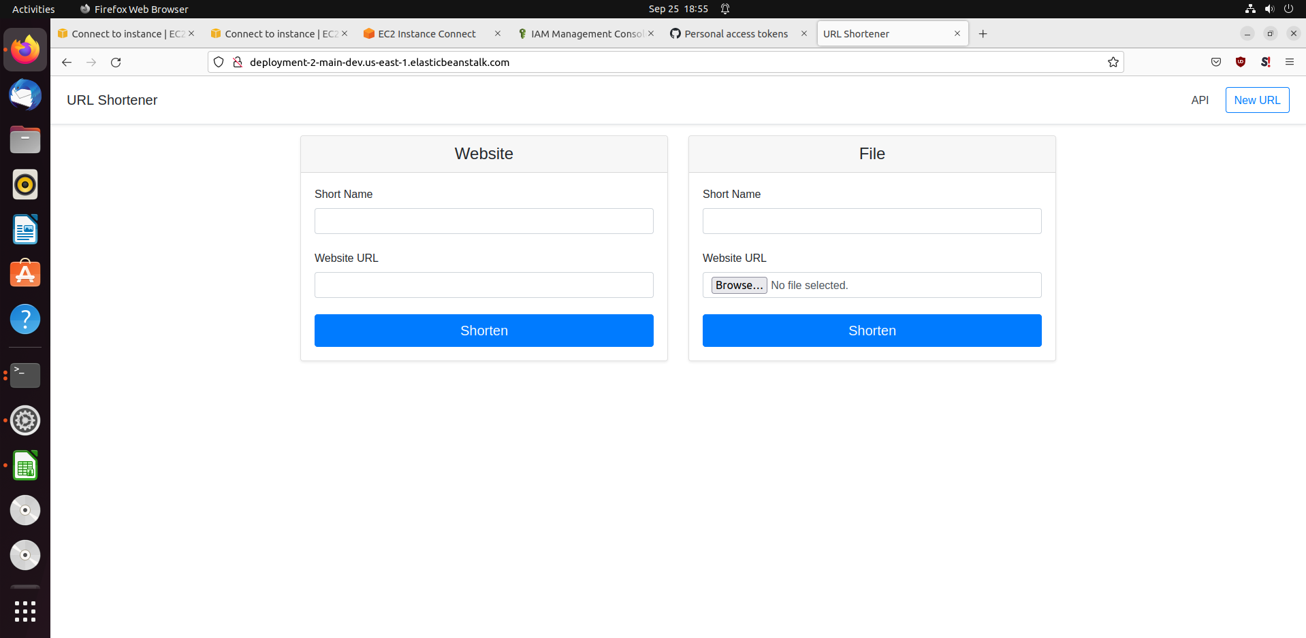

up and running; afterwards terminated environment.

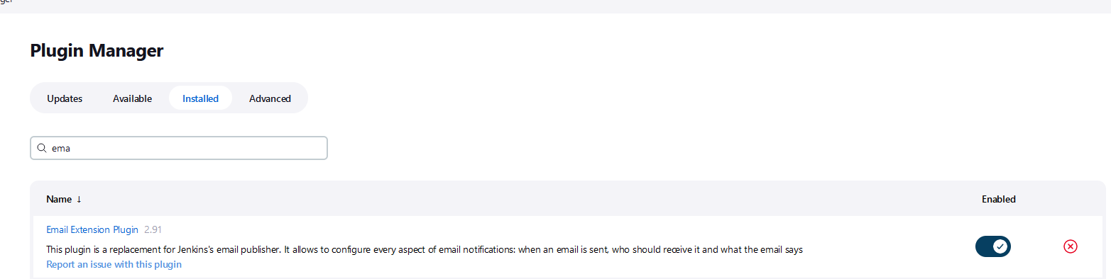

Added email extension plugin
Then went to manage jenkins → configure system → email notification
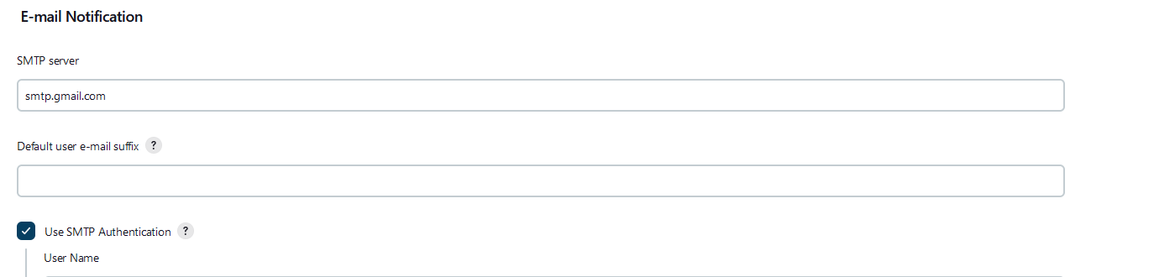
Set up credentials here
After editing my jenkinsfile I faced, numerous failures.

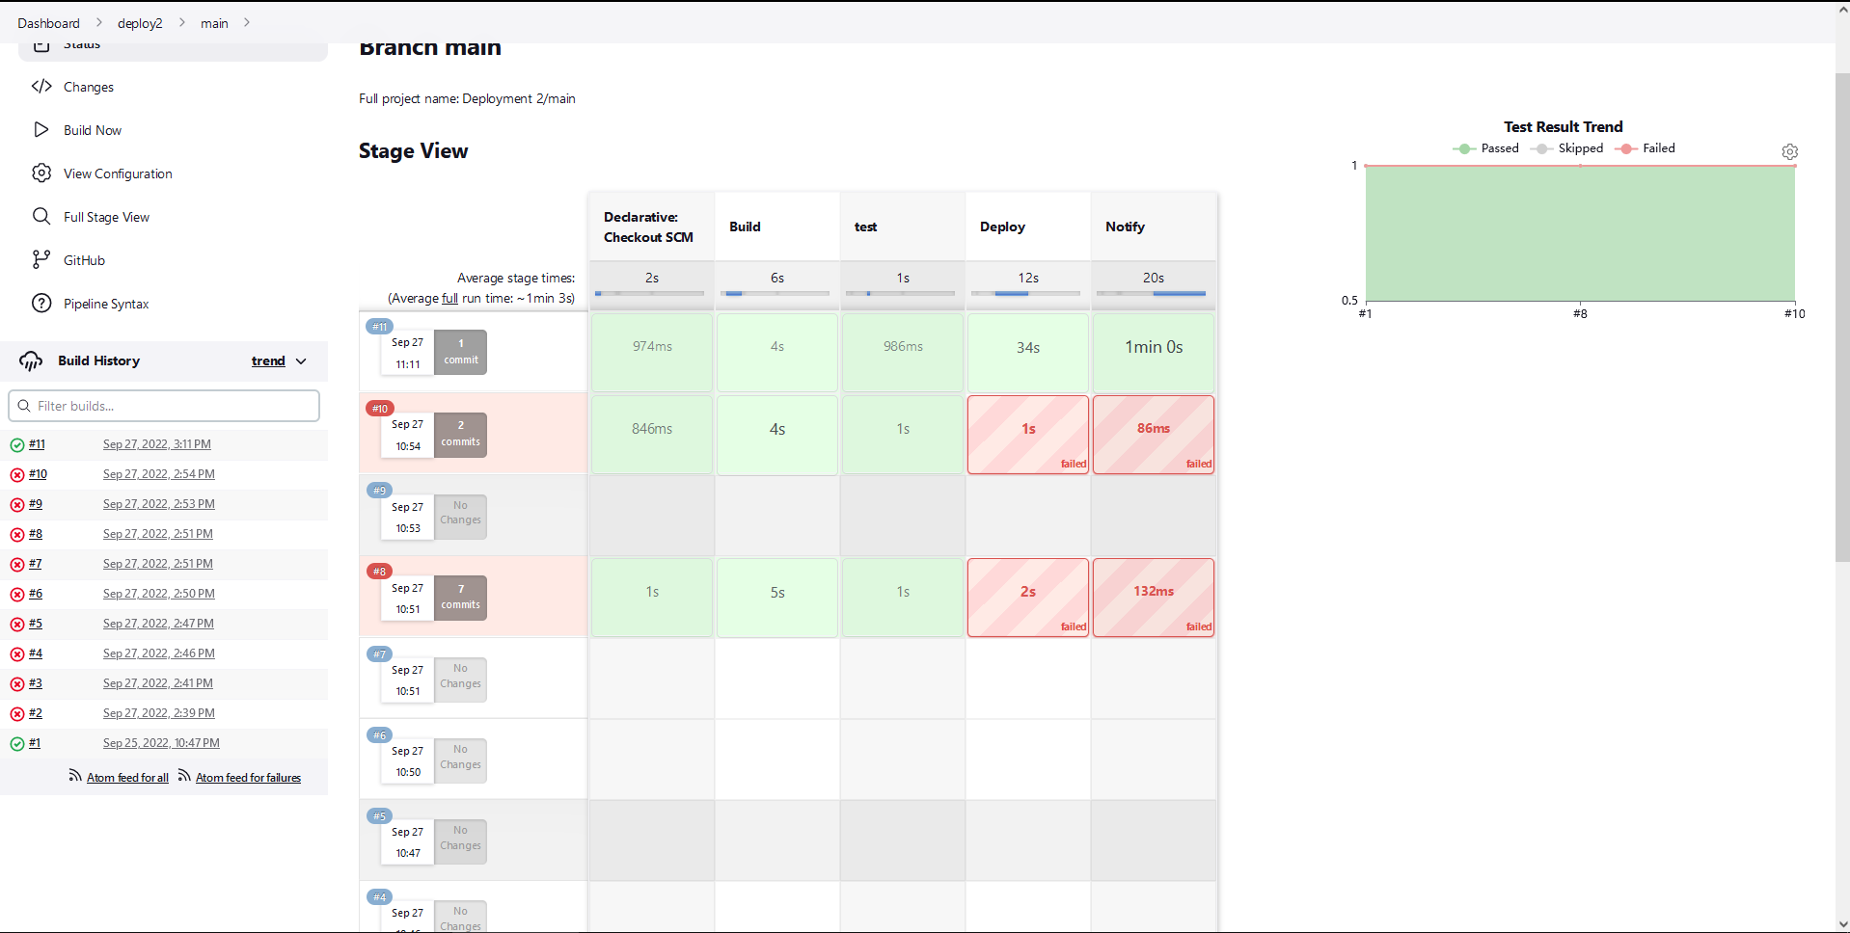
The reasons ranged from jenkinsfile indentations ; to the fact I terminated my application environment after the first deployment. It NEEDS to exist for the deploy step in the jenkinsfile to work. In terminating the environment, it won’t be able to find the environment name.
Checking the steps in jenkins shows how the extension handled email notification
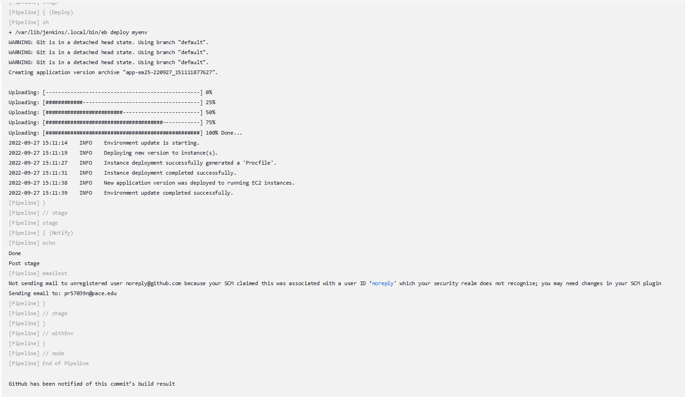

It took a while for the email to come through; but I got it.
Thus marking the end of the deployment.
